Evaluation: Random Forest
Accuracy: 0.9668
Precision: 0.9667919955179574
Recall: 0.9668
F1 Score: 0.9667243474144778
Jaccard Index: 0.9358260345004885
Matthews CorrCoef: 0.958535466468401
Cohen’s Kappa: 0.9585
Specificity: 0.9917
AUC: 0.9977824999999999
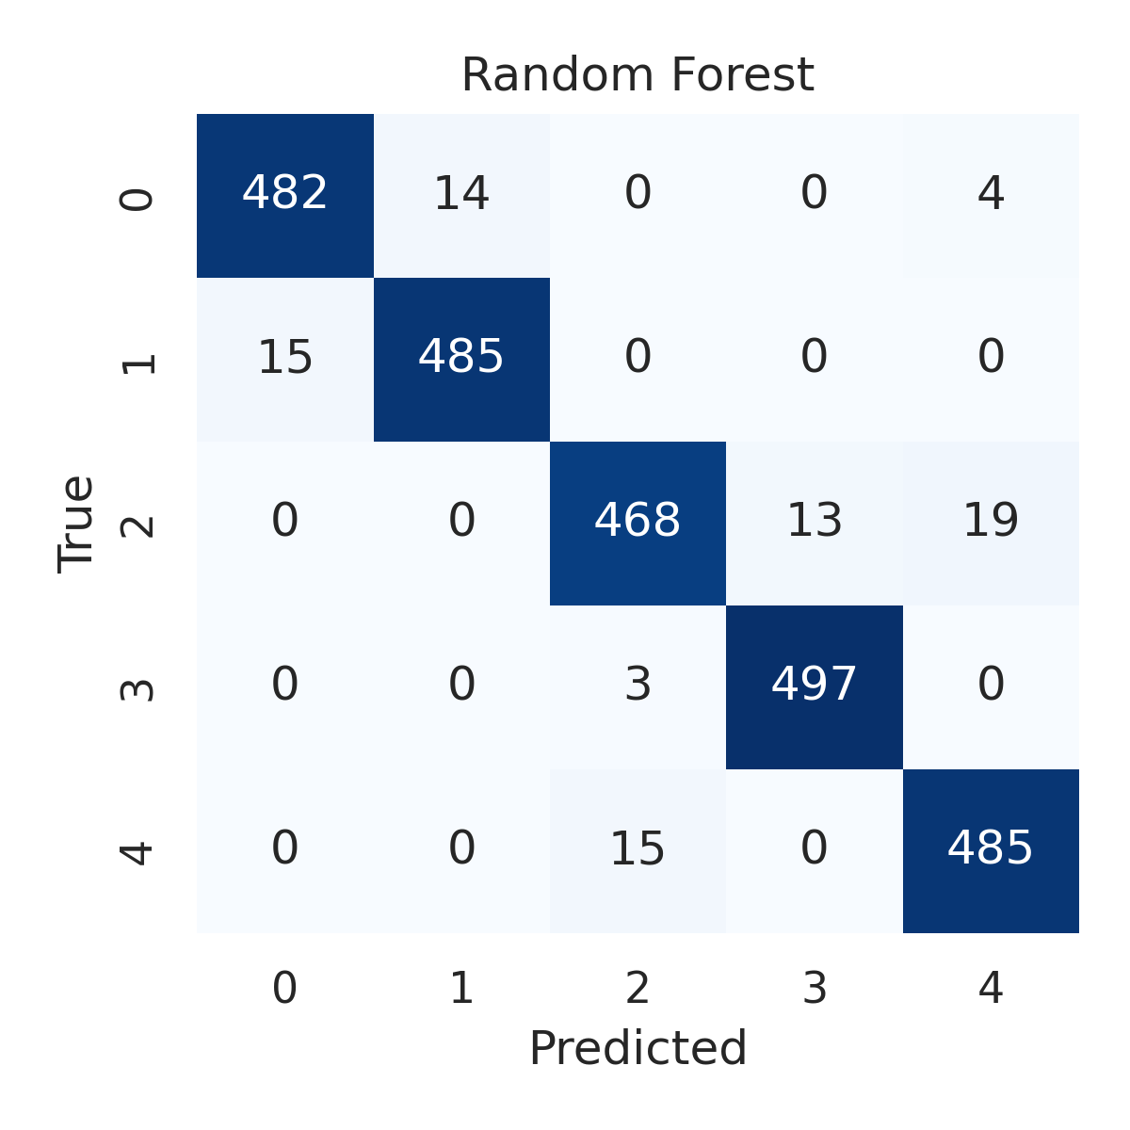

Combined ROC Curves
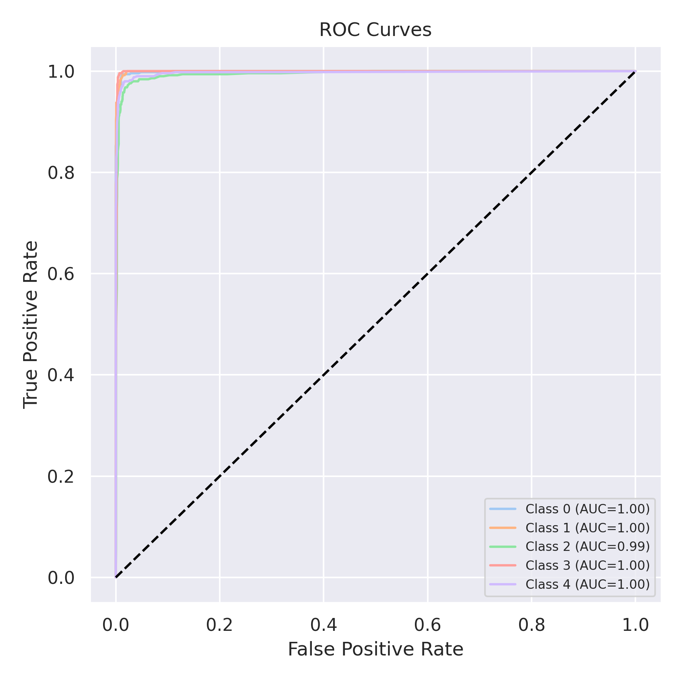

Evaluation: K-Nearest Neighbors
Accuracy: 0.884
Precision: 0.8867695379392415
Recall: 0.884
F1 Score: 0.8829683377576676
Jaccard Index: 0.7919280390170844
Matthews CorrCoef: 0.8561133287938546
Cohen’s Kappa: 0.855
Specificity: 0.9710000000000001
AUC: 0.9801766000000001
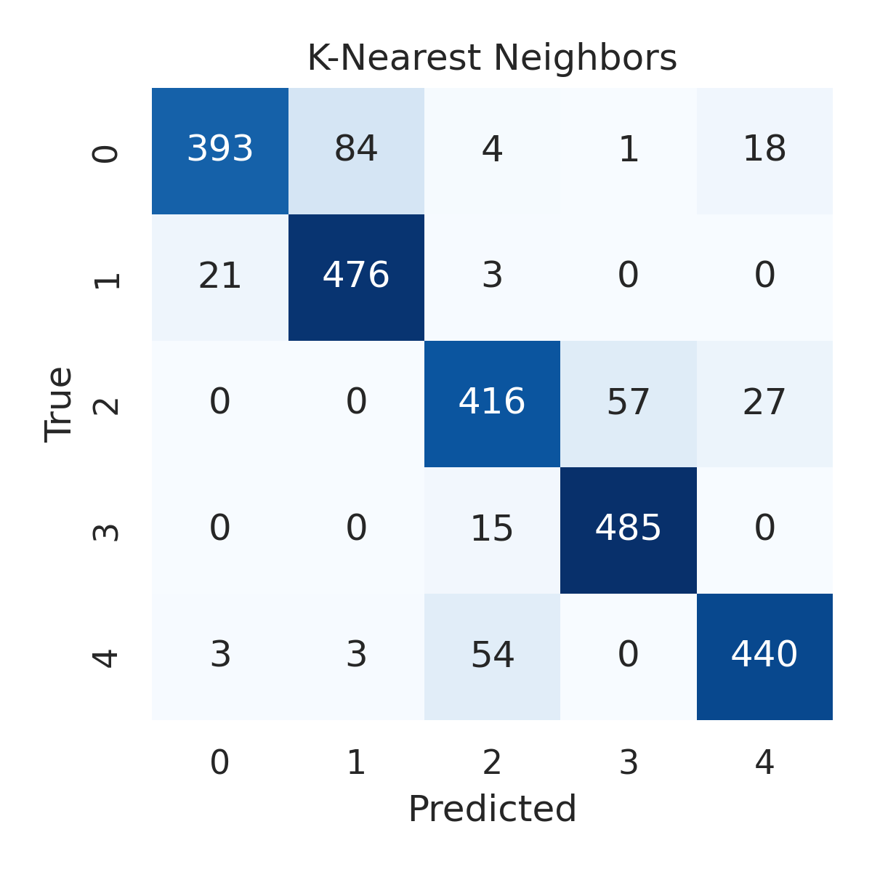

Combined ROC Curves
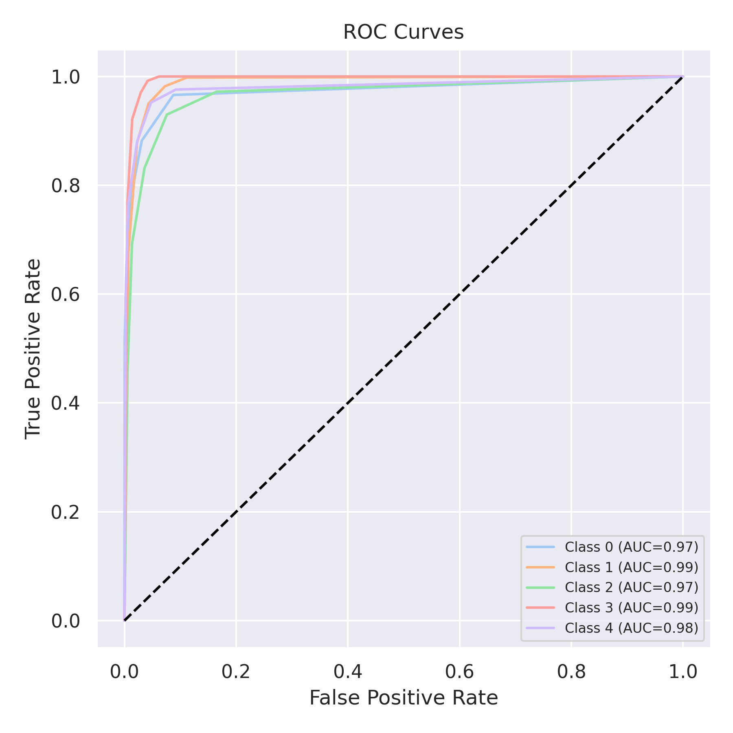

Evaluation: Decision Tree
Accuracy: 0.9632
Precision: 0.9631490391726902
Recall: 0.9632
F1 Score: 0.9631455002063333
Jaccard Index: 0.9294796758448789
Matthews CorrCoef: 0.954014310321983
Cohen’s Kappa: 0.954
Specificity: 0.9907999999999999
AUC: 0.977
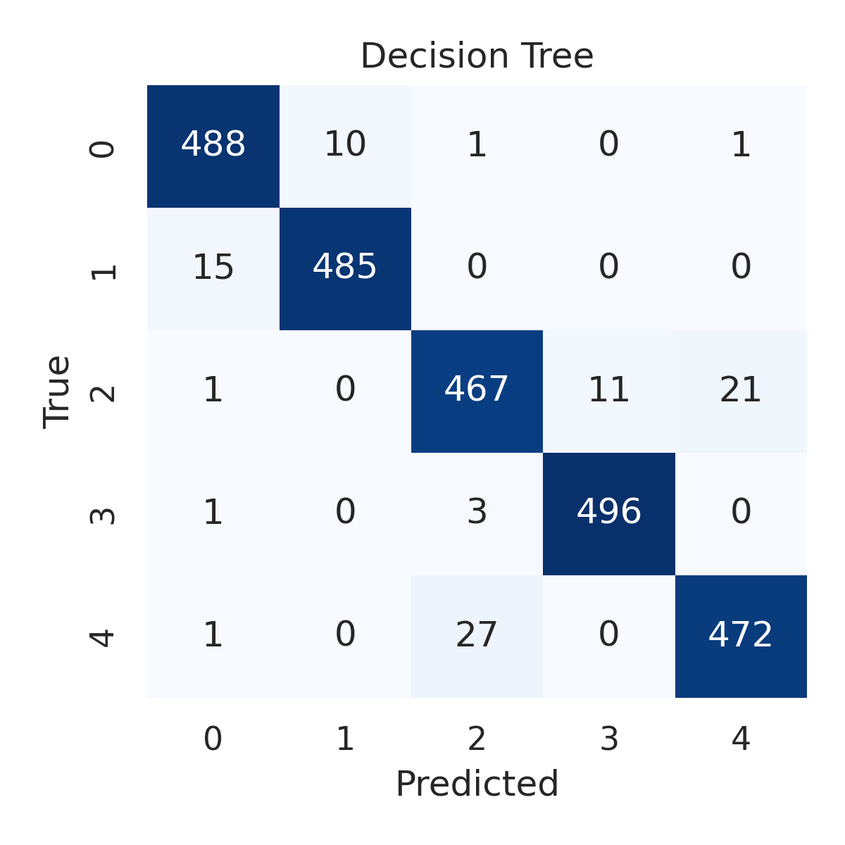

Combined ROC Curves
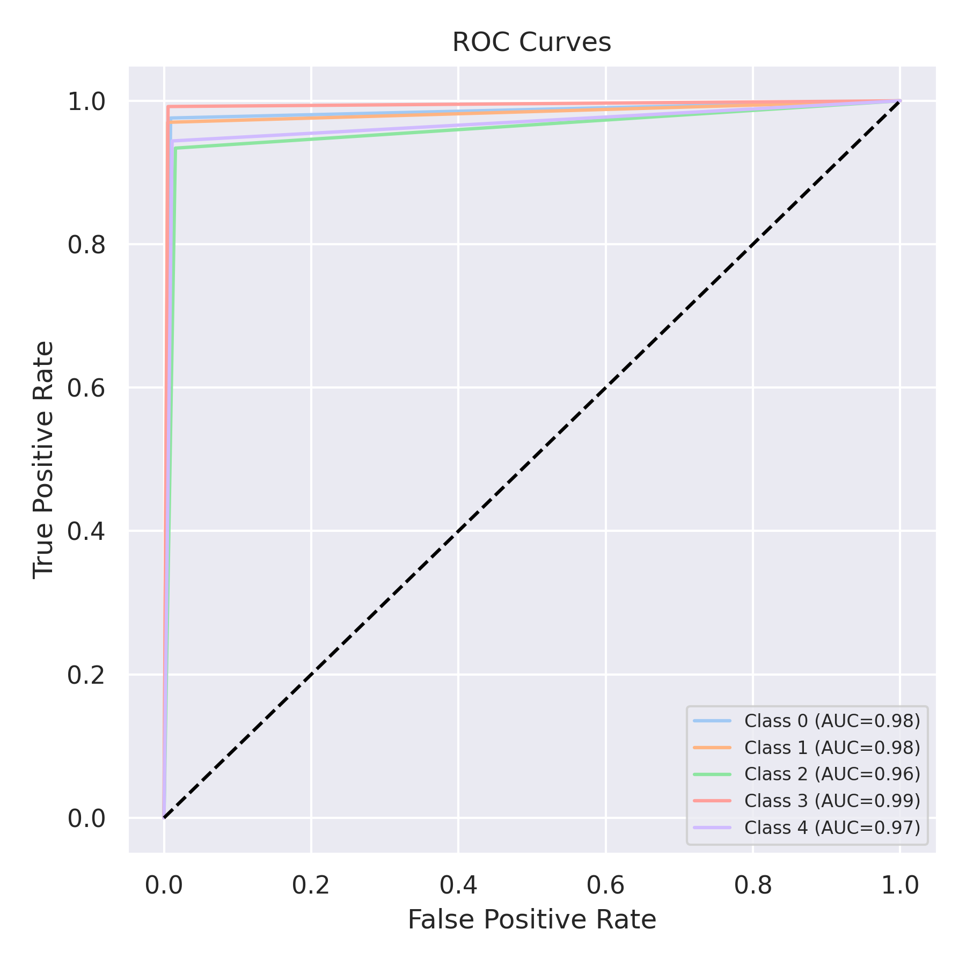

Evaluation: Extra Trees
Accuracy: 0.9692
Precision: 0.9691918699708436
Recall: 0.9692
F1 Score: 0.9691329797960457
Jaccard Index: 0.9403641051270073
Matthews CorrCoef: 0.961531346432849
Cohen’s Kappa: 0.9615
Specificity: 0.9923
AUC: 0.9984163
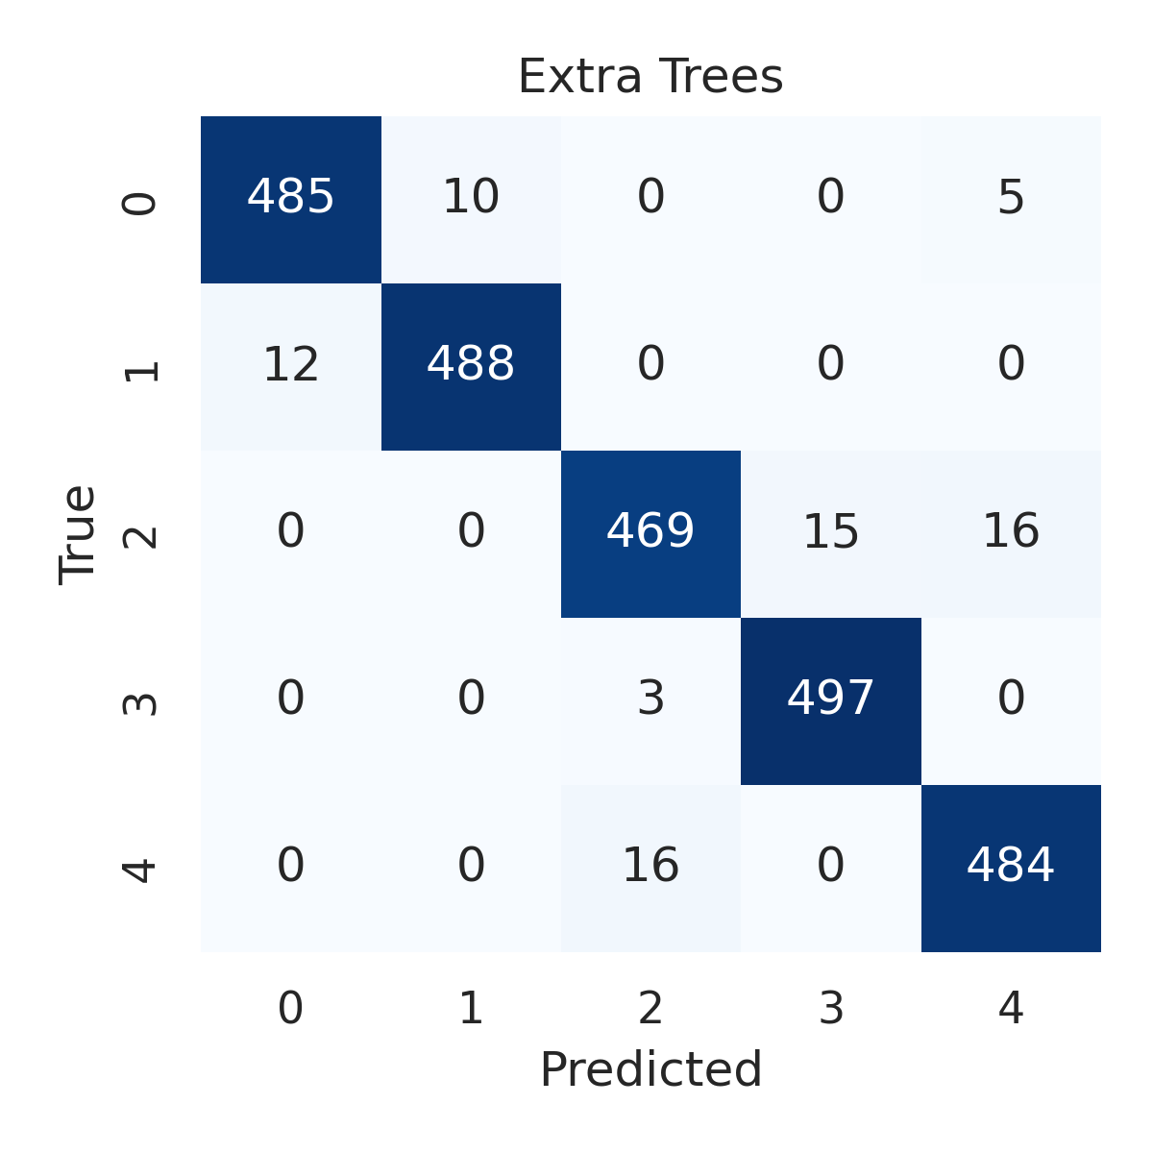

Combined ROC Curves
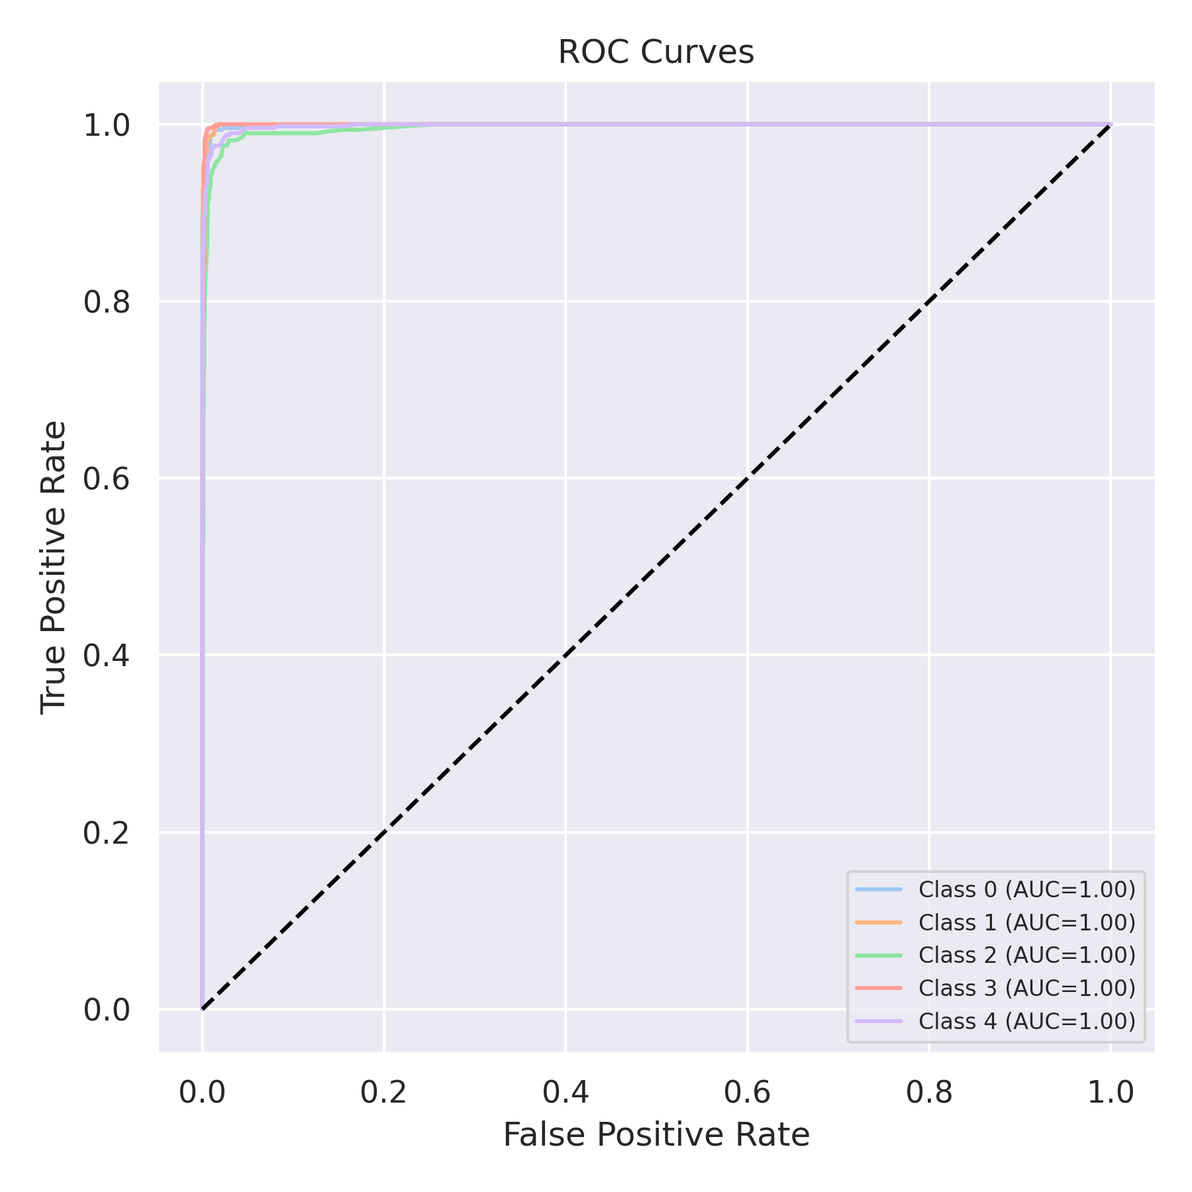

Evaluation: Bagging Classifier
Accuracy: 0.972
Precision: 0.9719444005111489
Recall: 0.972
F1 Score: 0.9719424254630287
Jaccard Index: 0.9456827336881306
Matthews CorrCoef: 0.9650148613432978
Cohen’s Kappa: 0.965
Specificity: 0.993
AUC: 0.9966063000000001
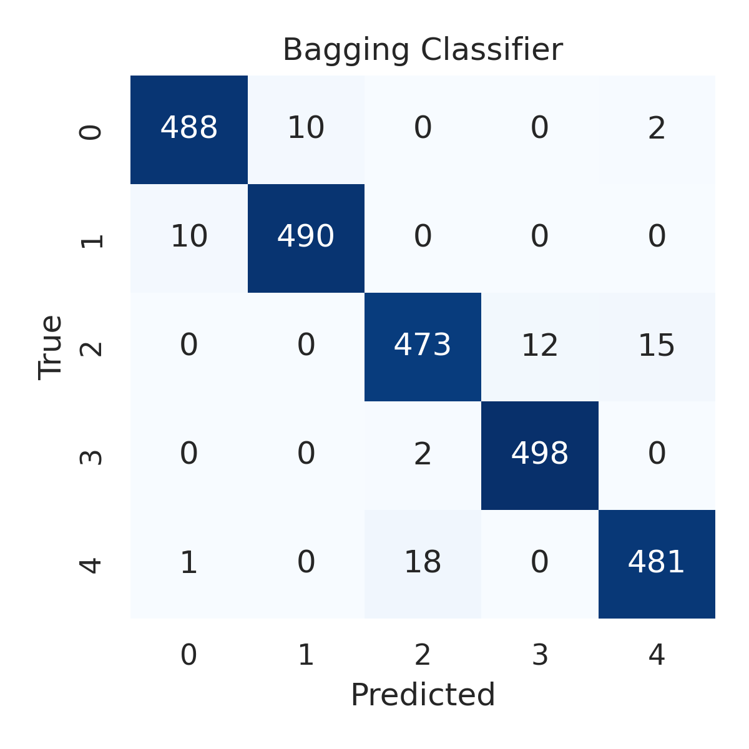

Combined ROC Curves
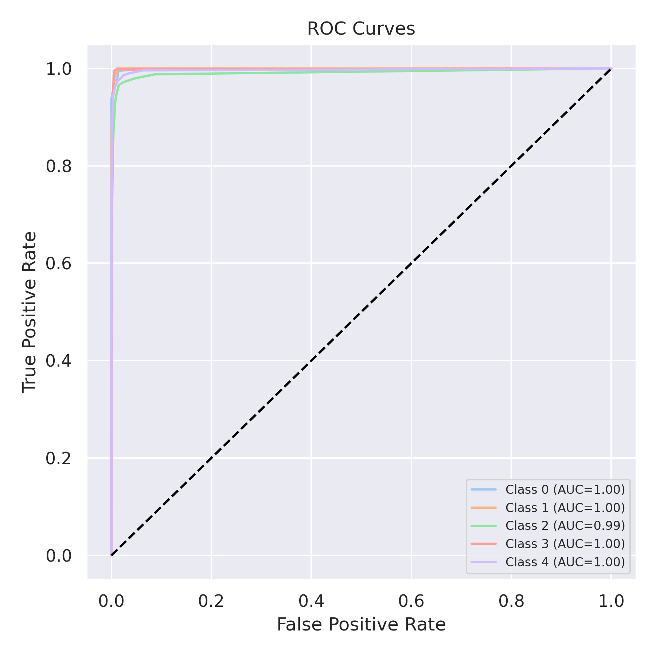

Evaluation: XGBoost
Accuracy: 0.98
Precision: 0.9800397728553449
Recall: 0.98
F1 Score: 0.9799581025865748
Jaccard Index: 0.9608898184971782
Matthews CorrCoef: 0.9750306164420419
Cohen’s Kappa: 0.975
Specificity: 0.9949999999999999
AUC: 0.9986639
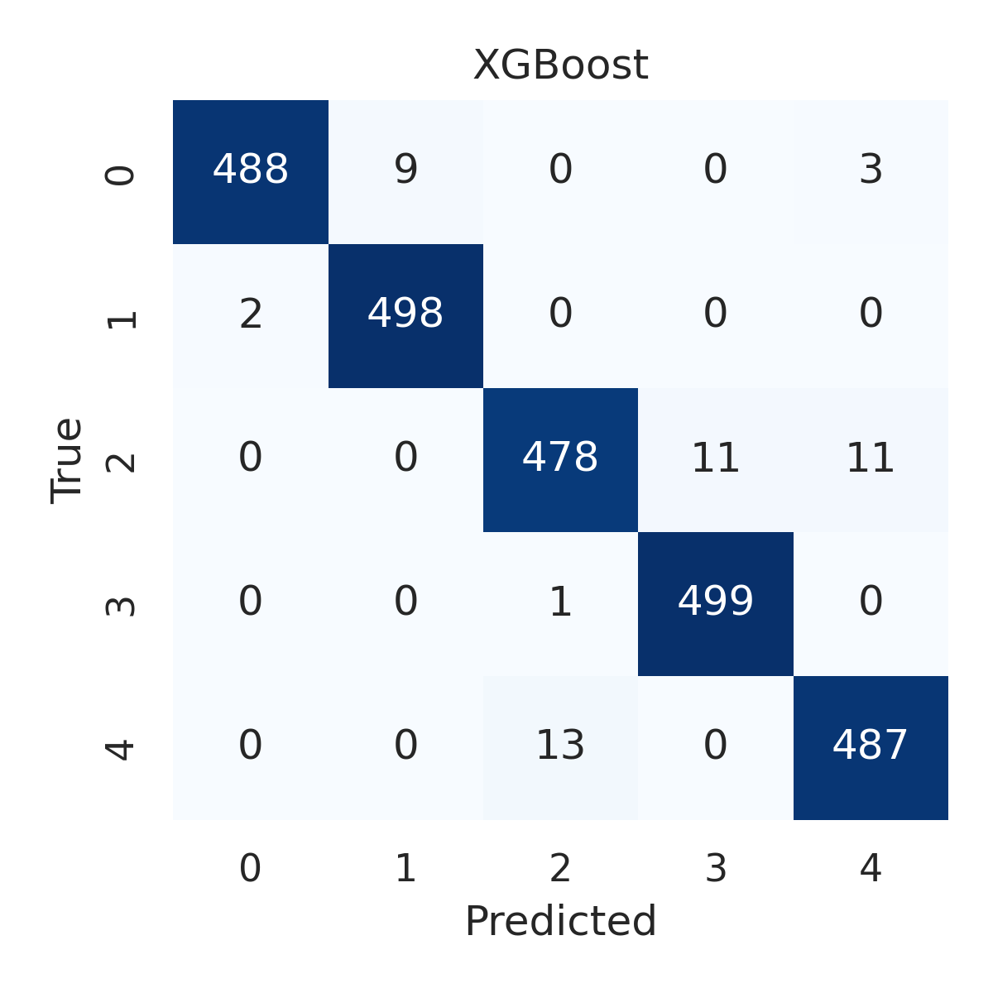

Combined ROC Curves
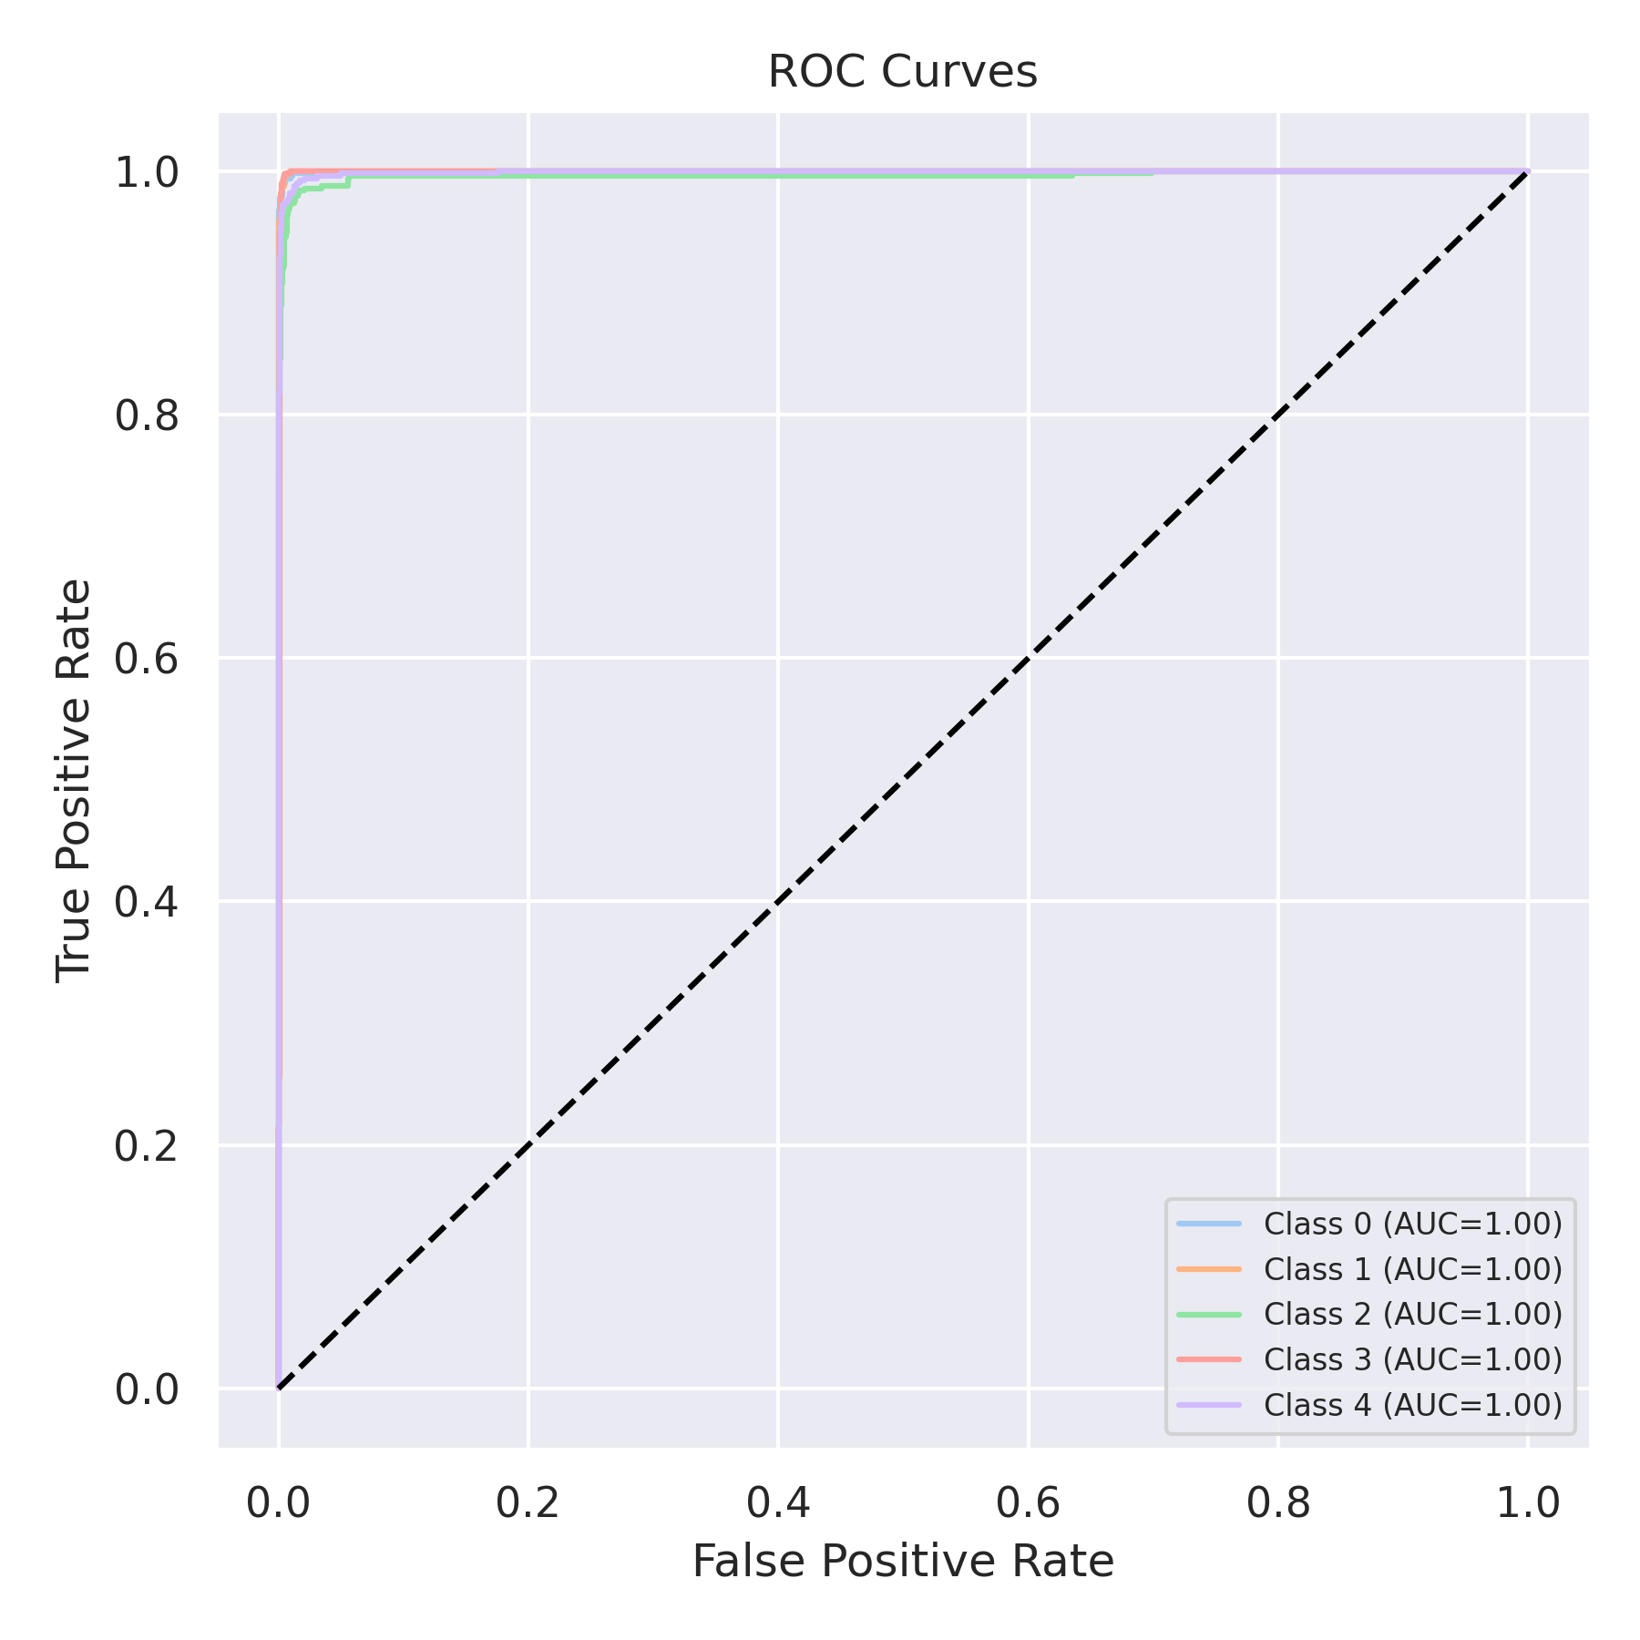

Evaluation: LightGBM
Accuracy: 0.9828
Precision: 0.9828192637726952
Recall: 0.9828
F1 Score: 0.9827644303557727
Jaccard Index: 0.9662562290015893
Matthews CorrCoef: 0.9785225062764695
Cohen’s Kappa: 0.9785
Specificity: 0.9957
AUC: 0.9985852
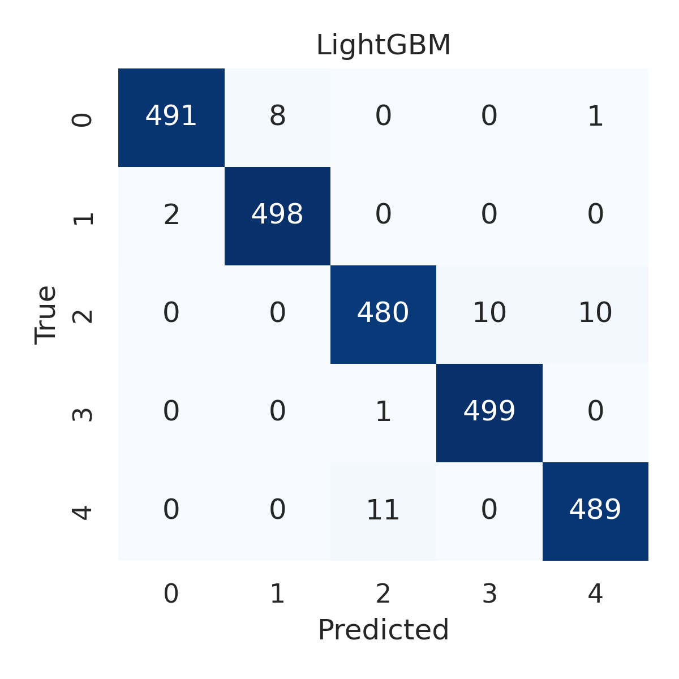

Combined ROC Curves
